Micellaneous Worksheet

Items highlighted in yellow are tasks for you to complete
Items in Purple italics are help tips

Mystery Calculator
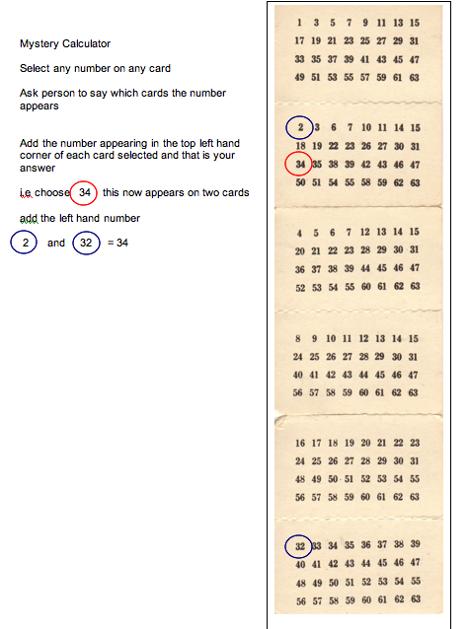



MATHEMATICIANS hunt elephants by going to Africa, throwing out everything that is not an elephant, and catching one of whatever is left.

EXPERIENCED MATHEMATICIANS will attempt to prove the existence of at least one unique elephant before proceeding to step 1 as a subordinate exercise.

PROFESSORS OF MATHEMATICS will prove the existence of at least one unique elephant and then leave the detection and capture of an actual elephant as an exercise for their graduate students.

